Project 1 Guide Index

Generic Tips

The Rubrics

Step 3 New Kernel Setup and Dependencies ! Very Important !

Step 3 Make Frame Size Error

Step 3 Kernel Build Taking Too Long?

Step 4 Tutorial

Step 4 Make Target Error

Step 4 Missing Module License Error

Step 5 Adding System Call Instructions

This is a collection of supplementary useful guides or frequently asked questions intended for the completion of Project 1, CSE 330. New materials may be appended to this document as the project proceeds and/or any unidentified issue surfaces.

- Yiran 'Lawrence' Luo

# Generic Tips

* This is a group project. One zipped submission of all required deliverables PER GROUP is sufficient.
* NEVER forget to put your teammates' names in the README.
* The bottom line is that your system starts and your custom kernel runs. All other peripherals (such as function names or custom kernel outputs) are mere decorations.
* For the sake of consistency, use the recommended Ubuntu VM specs as possible, unless you've already got an independent Linux machine.
* Be sure to reserve 50GB of space for the VM, or you will run into funny errors. You may install your VM on an external hard drive. A decent SSD with a USB 3.0 case is preferred.
* Follow the instructions rigorously, as you are supposed to.
* Use sudo and chmod 777 to blast through permission denials whenever necessary. It's a Virtual Machine for god's sake and you are supposed to mess it up whatsoever.
* Avoid using whitespaces when naming your files or directories, as ' ' could confuse both yourself and the machine in script files. If you have to, use _ instead, e.g. mkdir project_1

# The Rubrics

It's here: [Project 1 Rubrics](https://docs.google.com/document/d/1JEWWCGG8r0nkGhj5LumR9NxRcKSyLRDaVw33K0F8zZ4/edit?usp=sharing)

# Step 3 New Kernel Setup and Dependencies ! Very Important !

Accredited to 7StringsOvPasta from Linux User Group at ASU

<https://cdn.discordapp.com/attachments/929547467970715648/930929951048347758/VBoxSetupGuide.pdf>

Or

[VBoxSetupGuide.pdf](https://drive.google.com/file/d/1WJpT_J84zl8qbFiM9lwK2puUjmdVnDn3/view?usp=sharing)

Nearly 90% of foreseeable errors can be attributed to the environment being not set up properly. Reboot your VM after all the installations just in case.

# Step 3 Make Frame Size Error

Follow this example: <https://forums.debian.net/viewtopic.php?t=65980> and turn off the warming in the makefile.

# Step 3 Kernel Build Taking Too Long?

Richard — 01/11/2023 3:11 PM

@everyone sort of important so adding an @,

one additional step you can do to speed up kernel compilation (which can take HOURS on a slower PC) is to enable local modules only, which will only compile modules relevant to your "machine" (or in this case, relevant to your VM).

this sped up compilation on my fast PC from about 40 minutes to 10.

run this command before running your make command:

**make localmodconfig**

# Step 4 Tutorial

<https://www.youtube.com/watch?v=CWihl19mJig>

(added on Jan 30, 2023) In case you get confused watching the Step 4 video, here is a more straightforward code template for it, from Maple’s session

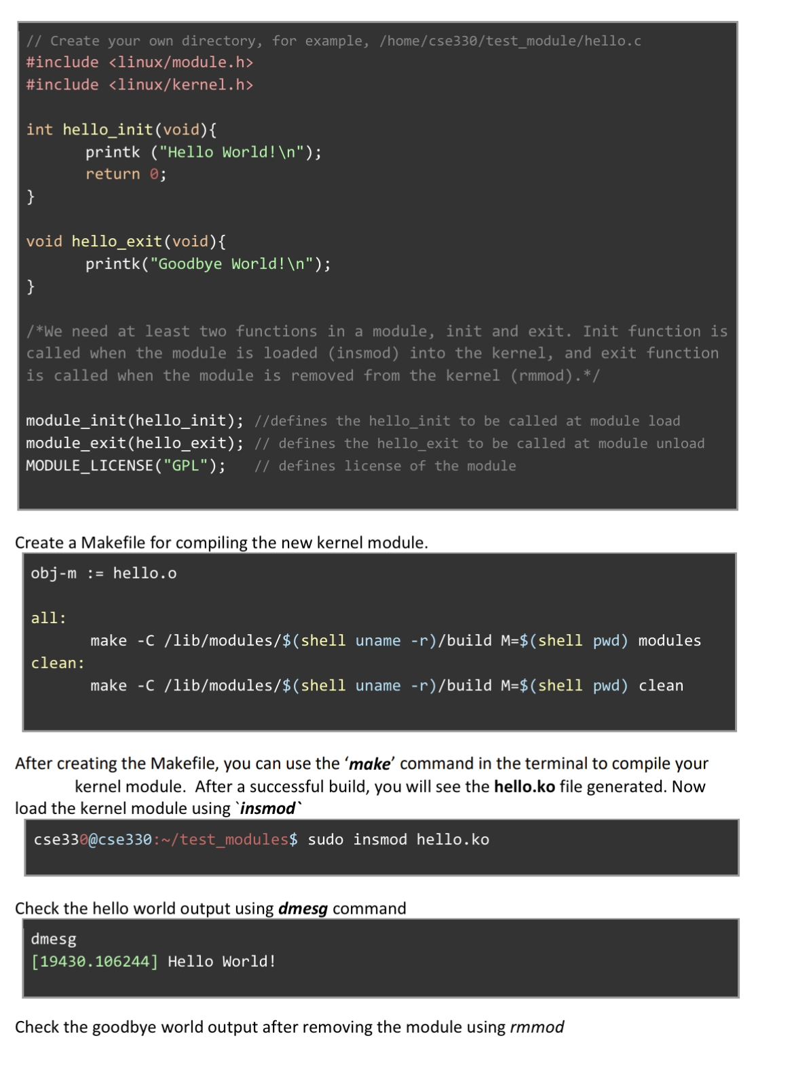

# Step 4 Make Target Error

Open the makefile and check if all involved files are accessible with the correct paths in it.

# Step 4 Missing Module License Error

Put this in your module .c code

MODULE_LICENSE("GPL");

# Step 5 Adding System Call Instructions

**Check this out (the recommended walkthrough)**

**​​**[**https://dev.to/jasper/adding-a-system-call-to-the-linux-kernel-5-8-1-in-ubuntu-20-04-lts-2ga8**](https://dev.to/jasper/adding-a-system-call-to-the-linux-kernel-5-8-1-in-ubuntu-20-04-lts-2ga8)

or

<https://medium.com/@jeremyphilemon/adding-a-quick-system-call-to-the-linux-kernel-cad55b421a7b>